**System Requirements**

**For**

**Travel Experts Project**

Table of Contents

Project Definition 3

Project Objectives 3

Functional Requirements 4

Technical Infrastructure Requirements 5

Requirement 5

Hierarchical Input Process Output Diagram 6

Data Flow Design Diagram 7

Data Flow Design Diagram (level-0) 8

# Project Definition

**Project Start Date:** September 12, 2016 **Project End Date:** December 16, 2016

## Project Objectives

The agency has determined that an easy-to-operate system for storing information on customers, suppliers, and sales is necessary. A centralized database designed and developed using Oracle will be generated and tested.

**Timeline:**

|  |  |  |  |  |  |
| --- | --- | --- | --- | --- | --- |
| **WBS** | **Tasks** | **Task Lead** | **Start** | **End** | Duration (Days) |
| **0** | **PROJECT** |  | 12-Sep-16 | 9-Dec-16 | 89 |
| **1** | **Initiation** |  |  |  |  |
| 1.1 | Submission of choice of group members |  |  | 21-Sep-16 | 9 |
| 1.2 | Project proposal |  |  | 5-Oct-16 | 12 |
| **2** | **Intermediate draft** |  |  |  |  |
| 2.1 | Conceptual model (ERD) |  |  | 19-Oct-16 | 37 |
| 2.2 | Initial relational model (logical) |  | 19-Oct-16 | 9-Nov-16 | 21 |
| 2.3 | Draft of functional part (programming) |  | 9-Nov-16 | 23-Nov-16 | 14 |
| **3** | **Final** |  |  | 16-Dec-16 | 89 |
| 3.1 | Final report with running application |  |  | 16-Dec-16 | 89 |

# Functional Requirements

User functionality and features (e.g. data entry, inquiries, on-line processing, reporting, performance expectations, system availability)

|  |  |  |
| --- | --- | --- |
| No. | Requirement | **M**andatory/ **W**ould Like |
| 1 | Data entry forms | M |
| 2 | Inquire customers for tracking commissions | W |
| 3 | Flexible reporting system | M |
| 4 | Fast and reliable system | M |
| 5 | All-time availability during work-hours: 9AM-5PM Monday to Saturday; closed on Sunday. | M |
| 6 | Intuitive graphical interface | M |
| 7 | Manager have full access | M |
| 8 | Online processing | M |

# Technical Infrastructure Requirements

* Development technologies
* Hardware (servers, desktop)
* Network
* Backup /recovery media

|  |  |  |
| --- | --- | --- |
| **No.** | Requirement | **Total Price** |
| 1 | **Development technologies**  Oracle Database 11g Standard Edition One with following features and price: (Prices in USA (Dollar)- based on oracle site)   * Named User Plus: $180 (x17) * Software Update-License & Support: $39.60 * Processor License: $5,800 * Software Update License & Support: $100,276.00 | **$ 120,000** |
| 2 | **Hardware (servers, desktop)**   * [HP DL380 G6 Server](http://www.nextag.com/HP-DL380-G6-Server-701380351/prices-html) with at least 4 hard drives: ([Hard Drives Direct](http://www.nextag.com/norob/PtitleSeller.jsp?chnl=main&ptitle=701380351&tag=824538631&ctx=6RogkOOS2nphJaFXqAG%2Fz5nwDev2BHvPIBEtGDMH6nykuuayWtI1OW%2B8FwU8y7SEFyVO%2BcMYn%2BJhVPiat%2BGpxLVTSAVI7a3eur%2BoQNFsR7wnO98X0Q%2Fkh4Le7xqNQmVt4TUhqaR13LwCEtAVK42ZYmm1drbcgFVlGxdUKaK%2FA32F0TosRMgEOgaYnYmel4imEy6BqfzFWJ%2BaaJh1OJdrhCl67nho6Cu05XmcHipSFdFaqW2t10xmnS3q66FvlsQkxelHg6zt7Szfs9VvPp%2FYEg%3D%3D) : $4,945 ) and one HP Monitor: $300 * 10x client-HP computer desktop system :10x 600.00=$6000 | **$ 70,000** |
| 3 | **Network**   * Cables * Switches * Routers | **$ 5,000** |
| 4 | **Backup / Recovery Media**   * External Hard Disk * Tape (Daily, Weekly, Monthly) | **$ 5,000** |

# Hierarchical Input Process Output Diagram

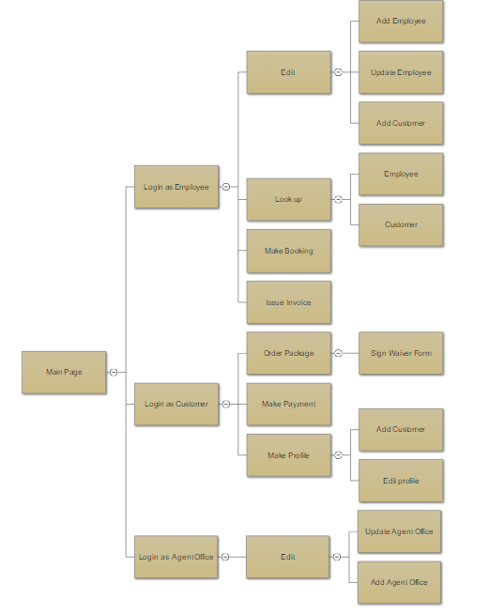

# Data Flow Design Diagram

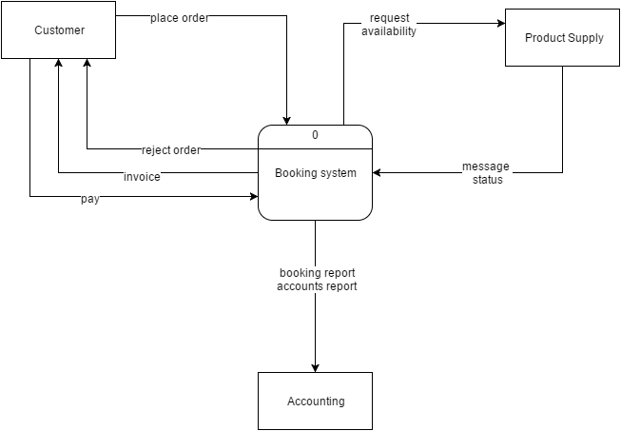

# Data Flow Design Diagram level-0 of booking system

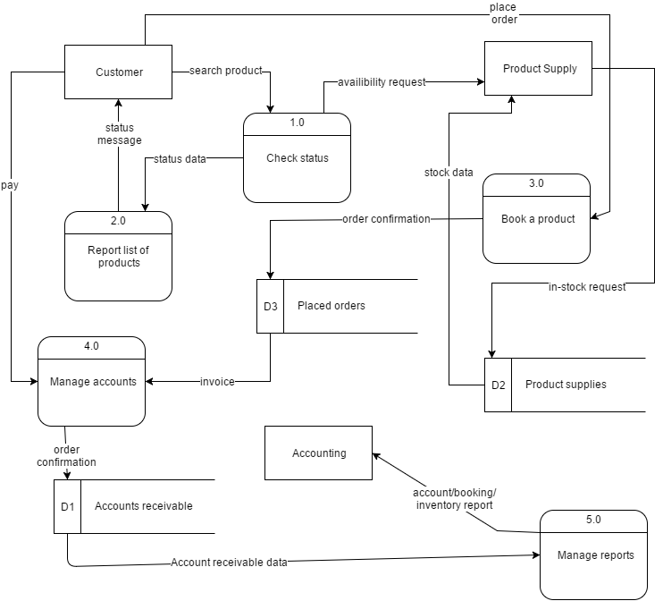References:

* + - 1. <http://www.projectsmart.co.uk/project-plans-10-essential-elements.html>
      2. <http://www.oracle.com/us/corporate/pricing/technology-price-list-070617.pdf>

1. <http://www.nextag.com/servers-HP-prices/compare-html?nxtg=4200a280506-9AF4D1A184FBE413>